沈远：垂钓
作品图片（Picture） | 作品图注（Caption_CN） | 作品图注（Caption_EN）
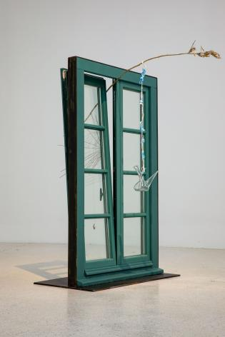 | 沈远  《垂钓巴黎的空气，2020》  2020  木窗、竹条、铜丝、玻璃、玻璃瓶、钢板  146 x 98 x 55 cm  红砖美术馆“垂钓”展览现场，2022 | Shen Yuan  Pêcher l'air de Paris 2020  2020  Wooden window, bamboo strip, copper wire, glass, glass bottle, steel plate  146 x 98 x 55 cm  “Angling” exhibition view at Red Brick Art Museum, 2022
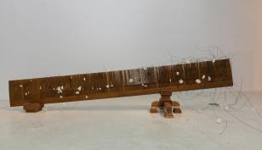 | 沈远  《记忆的碎片，2019》  2019  木头、铁丝、纸片560 x 160 x 216 cm  红砖美术馆“垂钓”展览现场，2022 | Shen Yuan  Fragments de mémoire 2019  2019  Wood, iron wire, paper sheet  560 x 160 x 216 cm  “Angling” exhibition view at Red Brick Art Museum, 2022
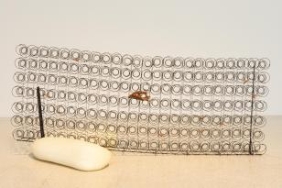 | 沈远  《Gazelles，1990-2020》  1990-2020  蜡、铁丝、铁条、铜丝、铜  196 x 75 x 14 cm, 97 x 74 x 20 cm  红砖美术馆“垂钓”展览现场，2022 | Shen Yuan  Gazelles 1990-2020  1990-2020  Wax, iron wire, iron bar, copper wire, copper  196 x 75 x 14 cm, 97 x 74 x 20 cm  “Angling” exhibition view at Red Brick Art Museum, 2022
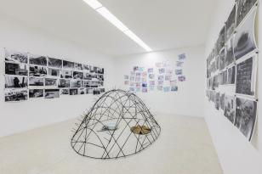 | 沈远  《马特奥和我，2019-2021》  2019-2021  图画、照片、铁笼、地毯、洗脸盆、抹布、影像  铁笼尺寸：240 x 175 x 120 cm，4A-35张  红砖美术馆“垂钓”展览现场，2022 | Shen Yuan  Mattéo et moi 2019-2021  2019-2021  Drawing, photograph, iron cage, carpet, basin, rag, video  Iron cage: 240 x 175 x 120 cm, 4A-35pages  “Angling” exhibition view at Red Brick Art Museum, 20222
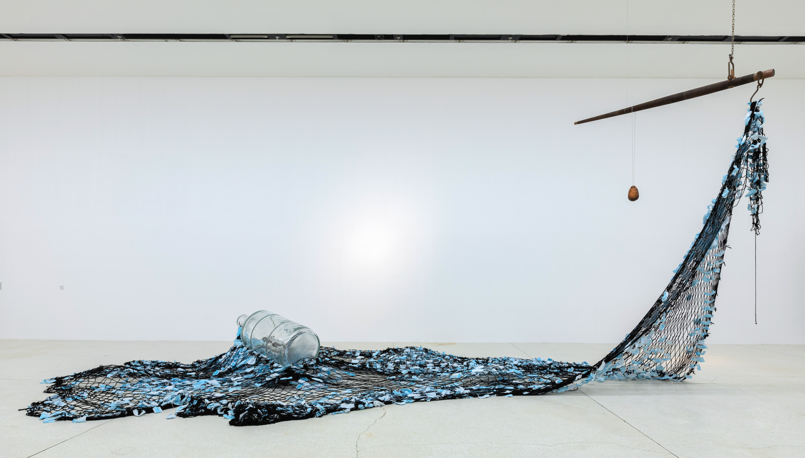 | 沈远  《漂流记，2020》  2020  琉璃瓶、渔网、铁架、秤砣、秤杆  700 x 1000 x 400 cm  红砖美术馆“垂钓”展览现场，2022 | Shen Yuan  Dérive 2020  2020  Glass bottle, fishing net, iron shelf, mass, beam  700 x 1000 x 400 cm  “Angling” exhibition view at Red Brick Art Museum, 2022
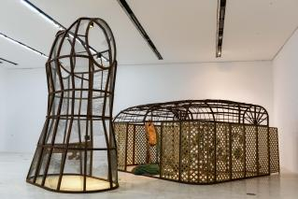 | 沈远  《阴性花园》  2017  铁架结构、铸铁喷泉、渔网、编织物、水  600 x 500 x 320 cm, 380 x 230 x 550 cm  红砖美术馆“垂钓”展览现场，2022 | Shen Yuan  La Jardin  2017  Iron structure, cast iron fountain, fishing net, fabric, water  600 x 500 x 320 cm, 380 x 230 x 550 cm  “Angling” exhibition view at Red Brick Art Museum, 2022

