趣时
作品图片（Picture） | 作品图注（Caption_CN） | 作品图注（Caption_EN）
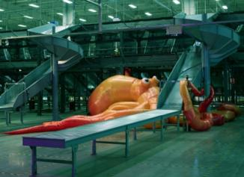 | 曹斐  《亚洲一号》  2018  单频高清影像，2.35:1，彩色，有声  63分21秒  作品由纽约所罗门·R·古根海姆美术馆为何鸿毅家族基金会中国艺术计划委任创作  图片由艺术家、维他命艺术空间及施布特-玛格画廊提供 | Cao Fei  Asia One  2018  Single channel HD video, 2.35:1, colour with sound  63’21’’  Commissioned by the Solomon R. Guggenheim Museum, New York, for The Robert H. N. Ho Family Foundation Chinese Art Initiative  Courtesy of the artist, Vitamin Creative Space and Sprüth Magers
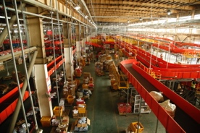 | 曹斐  《11.11》  2018  单频高清影像，16:9，彩色，有声  60分58秒  图片由艺术家、维他命艺术空间及施布特-玛格画廊提供 | Cao Fei  11.11  2018  Single channel HD video, 16:9, colour with sound  60’58’’  Courtesy of the artist, Vitamin Creative Space and Sprüth Magers
 | 克莱芒·科吉托尔  《殷勤的印第安人》  2017  彩色影像  6分钟  出品：巴黎歌剧院-第三舞台/佩雷亚影业  巴黎勒梅特收藏  图片由艺术家、德国莱因哈德·豪夫画廊和法国伊娃·霍伯画廊提供 | Clément Cogitore  Les Indes Galantes  2017  Video, color  6’  Production : Opera National de Paris - 3° scène/Les Films Pélléas  Lemaître collection, Paris  Courtesy: the artist, Reinhard Hauff Gallery, Germany and Eva Hober Gallery, France  ©Clément Cogitore
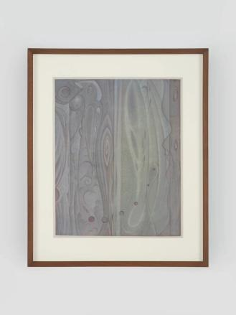 | 郝量  逍遥游与米家云山  2023  绢本水墨  画芯尺寸：35 × 28.4厘米  装框尺寸：47.2 × 39.2 × 3.3厘米  图片由艺术家和维他命艺术空间提供 | Hao Liang  Xiāoyáo yóu ("Wandering Boundless and Free") and Mi-family Cloudy Mountains  2023  Ink on silk  Image: 35 × 28.4 cm  Frame: 47.2 × 39.2 × 3.3 cm  Courtesy of the Artist and Vitamin Creative Space
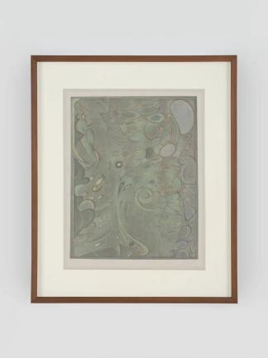 | 郝量  龟背竹  2023  绢本水墨  画芯尺寸：34.6 × 27.1厘米  装框尺寸：47.2 × 39.2 × 3.3 厘米  图片由艺术家和维他命艺术空间提供 | Hao Liang  Monstera Deliciosa  2023  Ink on silk  Image: 34.6 x 27.1 cm  Frame: 47.2 x 39.2 x 3.3 cm  Courtesy of the Artist and Vitamin Creative Space
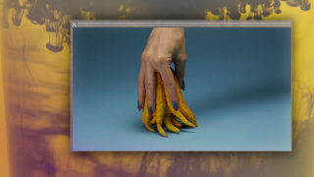 | 卡米耶·昂罗  《太累了》  2013  彩色有声  13分钟  图片由艺术家、塞莱克斯电影制作公司和巴黎卡迈勒·梅隆赫画廊提供 | Camille Henrot  Grosse Fatigue  2013  Sound, color  13’  Courtesy of the artist, Silex Films and kamel mennour, Paris
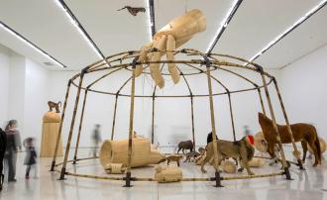 | 黄永砅  《马戏团》  2012  木头、竹子、动物标本、树脂、钢、线和布  841.1 × 1000.1 × 1000.1厘米图片由红砖美术馆提供 | Huang Yongping  Circus  2012  Wood, bamboo, taxidermy animals, resin, steel, cord and cloth  841.1 × 1000.1 × 1000.1cm  Courtesy of Red Brick Art Museum
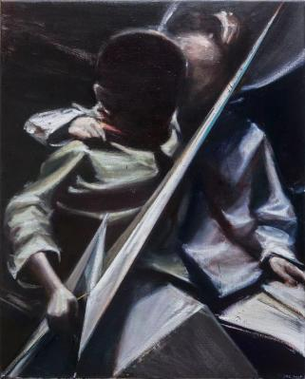 | 贾蔼力  《未命名》  2016  布面油画  100 × 80厘米  木外框配亚克力玻璃，尺寸：135 × 115 × 15 厘米  图片由艺术家和高古轩画廊提供 | Jia Aili  Untitled  2016  Oil on canvas  100 × 80cm  Frame: wooden frame with plexi-glass  135 × 115 × 15 cm  Courtesy of the artist
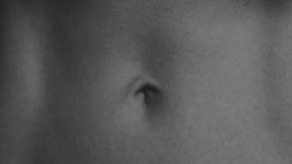 | 李怒  《世界》  2022  双频影像装置，黑白，无声  4分33秒  图片由艺术家和马刺画廊提供 | Li Nu  Mundus  2022  two-channel video installation, black and white, silent  04 '33"  Courtesy of the artist and SPURS Gallery
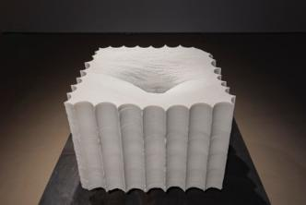 | 李怒  《世界》  2022  汉白玉  103 × 103 × 70厘米  图片由艺术家和马刺画廊提供 | Li Nu  Mundus  2022  White marble  103 × 103 × 70cm  Courtesy of the artist and SPURS Gallery
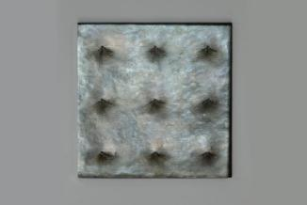 | 李怒  《世界就是世界》  2022  青铜  33 × 33 × 1.3厘米  图片由艺术家和马刺画廊提供 | Li Nu  Mundus Is Mundus  2022  Bronze  33 × 33 × 1.3 cm  Courtesy of the artist and SPURS Gallery
 | 李怒  《世界就是世界就是世界》  2022  青铜  99 × 99 × 1.9厘米  图片由艺术家和马刺画廊提供 | Li Nu  Mundus Is Mundus Is Mundus  2022  Bronze  99 × 99 × 1.9cm
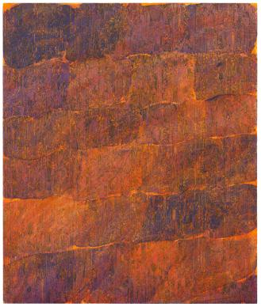 | 梁远苇  《2017.28》  2022  亚麻布上油画  190 × 160厘米  图片由私人收藏提供 | Liang Yuanwei  2017.28  2022  Oil on linen  190 × 160cm  Courtesy of private collection
 | 梁远苇  《2017 系列习作之一》  2017  亚麻布上油画  40 × 50厘米  图片由艺术家提供 | Liang Yuanwei  2017 Series Study A  2017  Oil on linen  40 × 50 cm  Courtesy of the artist
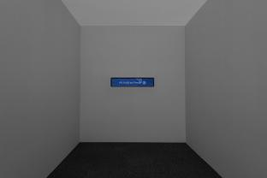 | 陶辉  《烟与光》  2021  单频道彩色有声录像装置，  12分36秒  屏幕: 22.1 × 110.1厘米  图片由艺术家，马凌画廊和施博尔画廊提供。  作品由光州国立亚洲文化殿堂委任创作。  "Refrigerator Illusion"展览现场，国立亚洲文化殿堂，光州，韩国，2021年 | Tao Hui  Smoke and Light  2021  Single channel video installation, color and sound  12’36’’  monitor: 22.1 × 110.1 cm  Image courtesy of the artist, Kiang Malingue and Esther Schipper Gallery.  Artwork commissioned by Asia Culture Center, Gwangju.  Installation view of “Refrigerator Illusion”, Asia Culture Center, Gwangju, South Korea, 2021.
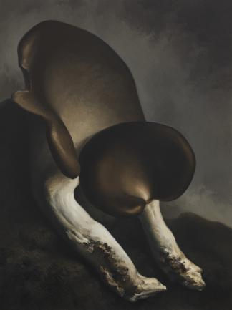 | 闫冰  《蘑菇 No.26》  2020  布面油画  200 × 150厘米  图片由私人收藏提供 | Yan Bing  Mushroom No.26  2020  Oil on canvas  200 × 150cm  Courtesy of private collection
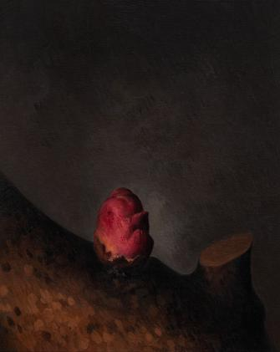 | 闫冰  《杏花 No.5 》  2019  布面油画  100 × 80厘米  图片由私人收藏提供 | Yan Bing  Apricot Flower No.5  2019  Oil on canvas  100 × 80cm  Courtesy of private collection
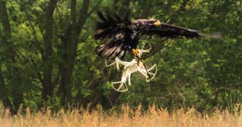 | 米尔恰·坎特尔  《鹰不捕蝇》  2018  无声彩色高清影像  3分40秒  图片由艺术家和德威赫画廊提供 | Mircea Cantor  Aquila Non Capit Muscas  （The eagle doesn’t hunt flies）2018  HD film color, mute  3’40”  Courtesy of the artist and VNH Gallery  ©Mircea Cantor
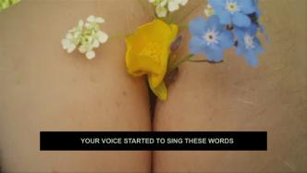 | 劳拉·普罗沃斯特  《尽其所有》  2015  高清影像  9分42秒  图片由红砖美术馆提供 | Laure Prouvost  Into All That Is Here  2015  HD Video  9’42’’  Courtesy of Red Brick Art Museum Collection
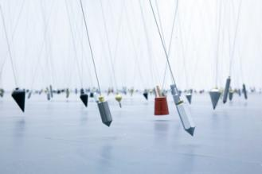 | 塔提亚娜·图薇  《指向无穷的750个点》  2009  铅垂线，磁铁，金属  尺寸可变  图片由红砖美术馆提供 | Tatiana Trouvé  750 Points towards Infinity  2009  Plumb lines, magnets, metal  Dimensions variable  Courtesy of Red Brick Art Museum

