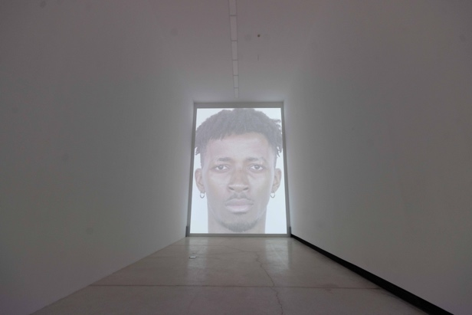 | 张培力  《2024的肖像》  2024  单视频录像投影，彩色，有声，  24分45秒  “张培力”，红砖美术馆展览现场，2024 | Zhang Peili  Portrait of 2024  2024  Single video projection, color, sound  24'45"  ZHANG Peili at Red Brick Art Museum, 2024
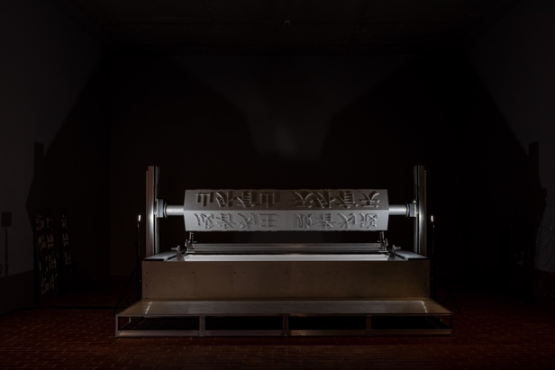 | 张培力  《压字机》  2024  机械装置 4mx2.8mx1.1m  机械臂、联轴器、减速机、控制器、砂料  “张培力”，红砖美术馆展览现场，2024 | ZHANG Peili  Word Press Machine  2024  Mechanical device, 4mx2.8mx1.1m  Mechanical arm, coupling, reducer, controller, sand  ZHANG Peili at Red Brick Art Museum, 2024
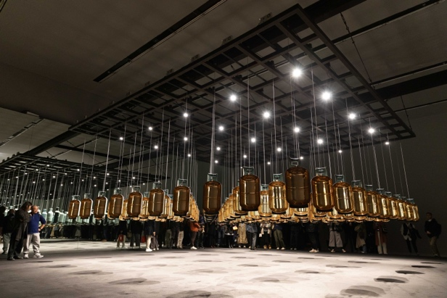 | 张培力  《煤气瓶阵列》  2024  机械装置 8mx8mx4m  电机、驱动器、控制器、煤气瓶、光轴、钢架、射灯  “张培力”，红砖美术馆展览现场，2024 | ZHANG Peili  Array of Propane Tanks  2024  Mechanical device, 8mx 8m x 4m  Motor, driver, controller, propane tanks, optical shaft, steel frame, spotlight  ZHANG Peili at Red Brick Art Museum, 2024
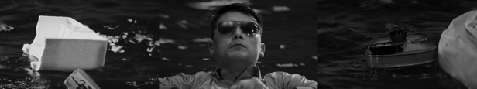   | 张培力  《海上》  2024  三通道录像投影，彩色，有声，运用AI技术  17分36秒  “张培力”，红砖美术馆展览现场，2024 | ZHANG Peili  At Sea  2024  3-channel video projection, color, sound, utilizing AI technology  17'36"  ZHANG Peili at Red Brick Art Museum, 2024
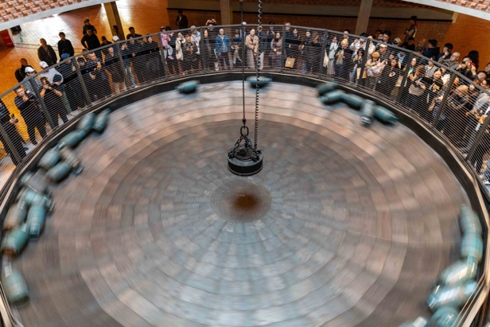 | 张培力  《不断旋转》  2024  机械装置  圆锅直径 960 cm，深 116 cm  废旧的煤气瓶若干个、变频电机、电磁铁、钢网  “张培力”，红砖美术馆展览现场，2024 | ZHANG Peili  Constant Rotation  2024  Mechanical device with a round pot, diameter 960 cm, depth 116 cm  Several discarded propane tanks, variable frequency motor, electromagnet, steel mesh  ZHANG Peili at Red Brick Art Museum, 2024
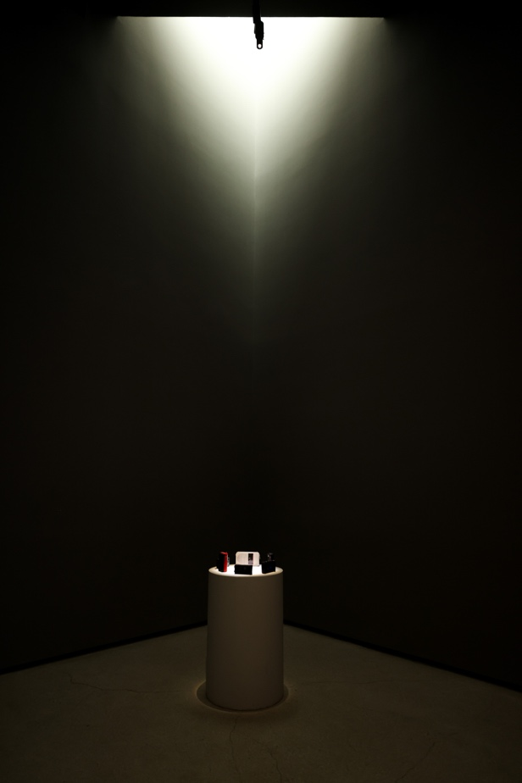 | 张培力  《围成圆圈的半导体收音机》  2019  机械装置 直径 60 cm，高 90 cm  旧半导体收音机  “张培力”，红砖美术馆展览现场，2024 | ZHANG Peili  Semiconductor Radios in a circle  2019  Mechanical device, diameter 60 cm, height 90 cm  Old semiconductor radios  ZHANG Peili at Red Brick Art Museum, 2024
 | 张培力  《一分钟一个字》  2015  LED 显示屏  16 cm x 16 cm x 4 cm  “张培力”，红砖美术馆展览现场，2024 | ZHANG Peili  One Minute One Word  2015  LED display screen  16 cm x 16 cm x 4 cm  ZHANG Peili at Red Brick Art Museum, 2024
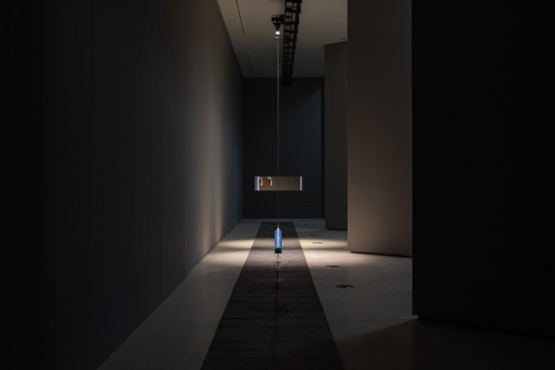 | 张培力  《拖拽模式》  2024  机械装置  2400 cm x 40 cm  导轨、齿轮、伺服电机、氧气瓶、钢板、钢丝绳  “张培力”，红砖美术馆展览现场，2024 | ZHANG Peili  Dragging Mode  2024  Mechanical device  2400 cm x 40 cm  Guide rail, gear, servo motor, oxygen tank, steel plate, steel wire rope  ZHANG Peili at Red Brick Art Museum, 2024
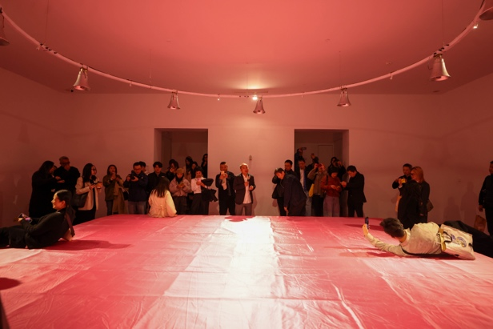 | 张培力  《方形的音响床垫》  2024  感应声音装置  600 cm x 600 cm x 50 cm  床垫、压力传感控制器、音响  “张培力”，红砖美术馆展览现场，2024 | ZHANG Peili  Square sound Mattress  2024  Sound sensor device  600 cm x 600 cm x 50 cm  Mattress, pressure sensor controller, sound system  ZHANG Peili at Red Brick Art Museum, 2024
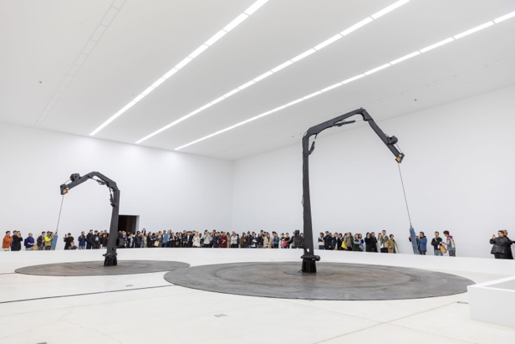 | 张培力  《两个同心圆的拖拽模式》  2024  机械装置  大吊机  1160 cm x 1160 cm x 600 cm  小吊机  760 cm x 760 cm x 400 cm  机械臂、plc 控制器、油泵、齿盘、钢板、氧气瓶  “张培力”，红砖美术馆展览现场，2024 | ZHANG Peili  Two Mechanical Devices Moving in Concentric Circles  2024  Mechanical device: large crane 1160 cm x 1160 cm x 600 cm, small crane 760 cm x 760 cm x 400 cm  Mechanical arm, plc controller, oil pump, gear plate, steel plate, oxygen tanks  ZHANG Peili at Red Brick Art Museum, 2024
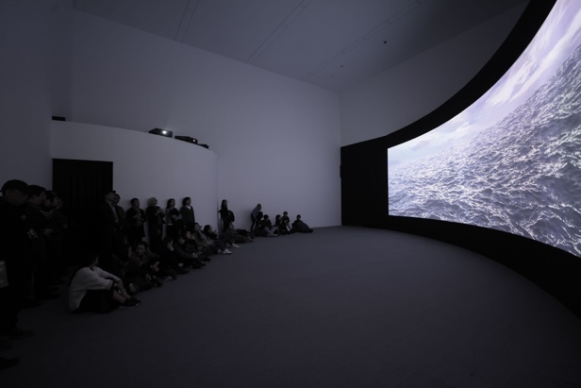 | 张培力  《海上》  2024  三通道录像投影，彩色，有声，运用 AI 技术  17分36秒  “张培力”，红砖美术馆展览现场，2024 | ZHANG Peili  At Sea  2024  3-channel video projection, color, sound, utilizing AI technology  17'36''  ZHANG Peili at Red Brick Art Museum, 2024
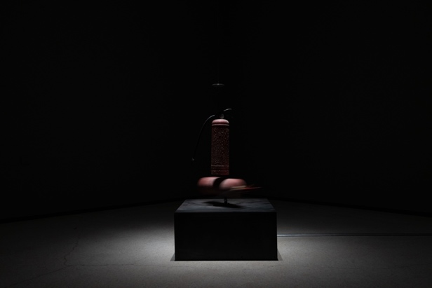 | 张培力  《温柔地碰撞》  2024  机械装置 尺寸可变  80 cm x 80 cm  灭火器、绞盘电机、钢丝绳  “张培力”，红砖美术馆展览现场，2024 | ZHANG Peili  Gentle Touch  2024  Mechanical device, variable dimensions  80 cm x 80 cm  Fire extinguishers, winch motor, steel wire rope  ZHANG Peili at Red Brick Art Museum, 2024
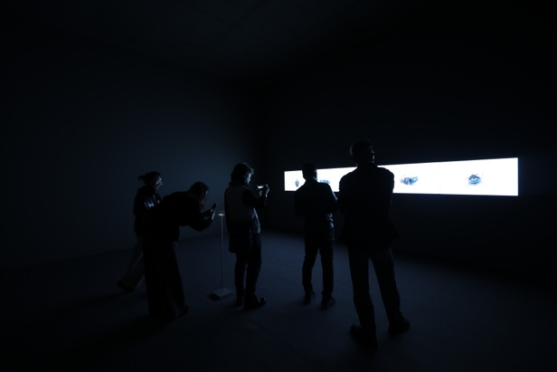 | 张培力  《一个生命的最后几分钟》  2024  五通道录像，彩色，无声  4分03秒  “张培力”，红砖美术馆展览现场，2024 | ZHANG Peili  The last few minutes of life  2024  Five-channel video recording, color, silent  4'03''  ZHANG Peili at Red Brick Art Museum, 2024
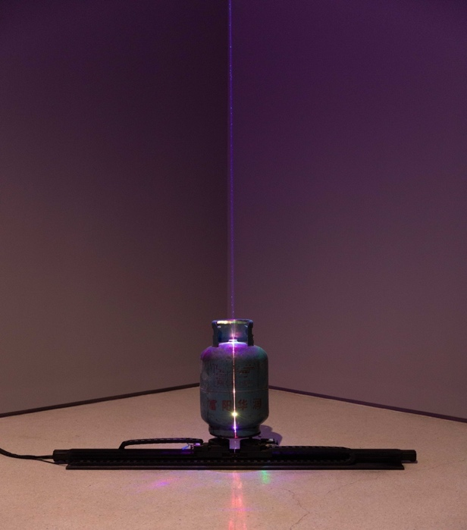 | 张培力  《可以分合的煤气瓶（一）》  2024  机械装置  200 cm x 30 cm x 170 cm  煤气瓶、激光灯、轨道、旋转平台，电机、自动控制系统  “张培力”，红砖美术馆展览现场，2024 | ZHANG Peili  Divisible Propane Tank I  2024  Mechanical device  200 cm x 30 cm x 170 cm  Propane tank, laser light, track, rotating platform, motor, automatic control system  ZHANG Peili at Red Brick Art Museum, 2024
 | 张培力  《可以分合的煤气瓶（二）》  2024  机械装置  175 cm x 30 cm x 90 cm  煤气瓶、激光灯、轨道、旋转平台，电机、自动控制系统  “张培力”，红砖美术馆展览现场，2024 | ZHANG Peili  Divisible Propane Tank II  2024  Mechanical device  175 cm x 30 cm x 90 cm  Propane tank, laser light, track, rotating platform, motor, automatic control system  ZHANG Peili at Red Brick Art Museum, 2024
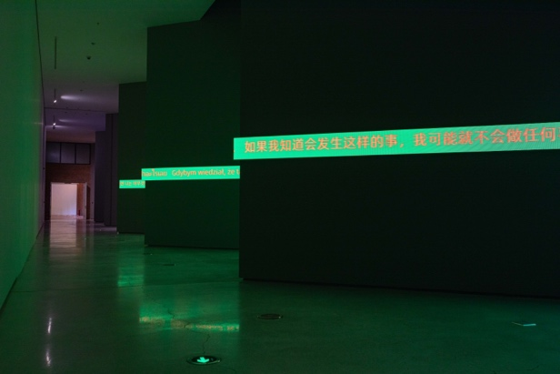 | 张培力  《标准翻译》  2024  LED 摄影装置，彩色，无声  200 cm x 200 cm  “张培力”，红砖美术馆展览现场，2024 | ZHANG Peili  Standard Translation  2024  LED photographic installation, color, silent  200 cm x 200 cm  ZHANG Peili at Red Brick Art Museum, 2024
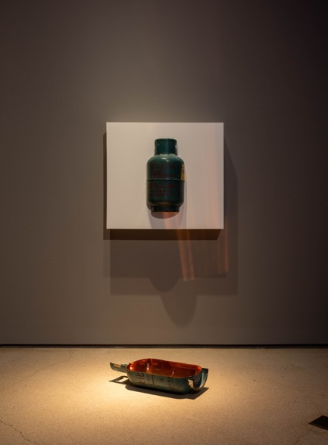 | 张培力  《嵌在墙中的煤气瓶》  2024  装置 煤气瓶  32 cm x 70 cm  “张培力”，红砖美术馆展览现场，2024 | ZHANG Peili  Embedded Propane Tank in the wall  2024  Installation  Propane tank  32 cm x 70 cm  ZHANG Peili at Red Brick Art Museum, 2024
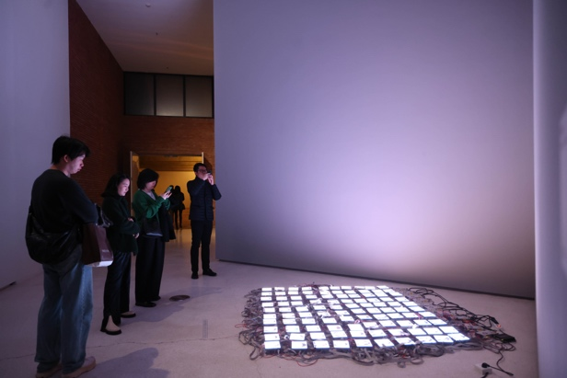 | 张培力  《标准像》  2024  LED 摄影装置，彩色，无声  200 cm x 200 cm  “张培力”，红砖美术馆展览现场，2024 | ZHANG Peili  Standard Portraits  2024  LED photographic installation, color, silent  200 cm x 200 cm  ZHANG Peili at Red Brick Art Museum, 2024

